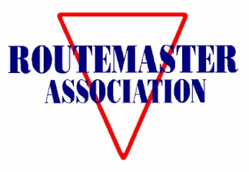

MEMBERSHIP FORM
1st October 2025 to 30th September 2026

Please PRINT clearly in block capitals [If your details have changed, please amend them using the area at the bottom of this form.]

Mr. Mrs. Miss. Ms. / Forename / Surname: ___________________________________________________________________________________________________________
Membership No (If renewing).____________

Renewal rates: The amount in brackets is payable if not renewing by Direct Debit through Go-Cardless
Where you live | 1 copy of each issue | 2 copies of each issue | 3 copies of each issue
UK | £25 (£30) | £33 (£38) | £44 (£49)
Europe / EU | £30 (£35) | £40 (£45) | £50 (£55)
Outside Europe | £34 (£39) | £46 (£51) | £58 (£63)
Digital Option | £15 (£20) | - | -
To pay by Direct Debit please type https://pay.gocardless.com/AL0002W2R99H21 into your internet browser and fill in the screen which appears. (If you did this last year, you do not have to do it again.) Using direct debit saves you £5 each year.
Payments can also be made (at the higher cost in brackets) through the Routemaster website via PayPal or can be sent to: Pay2@routemaster.org.uk. Please use your surname and membership number as a reference number.
If paying by cheque (at the price in brackets and in Pounds Sterling only) payable to 'Routemaster Association', please send it with this form to:
Routemaster Association Membership, 9 Brunel Way, Dartford, Kent, DA1 5FL, United Kingdom.
Please state here how much the cheque is for £…………………
For members outside the UK, if you are unable to use the Direct Debit system or PayPal, please contact the Membership Secretary (email to membership@routemaster.org.uk) and we can supply further options.
Signed: ...................................................................…......... Date: ............……................................
Your Contact Details:
Address.
 | Postcode
Telephone numbers | Home
 | Mobile
Email address
Please help us to improve our parts supply and technical services by indicating below any buses you own or are responsible for.

